TUTORIAL 6 -MNGMAK013

A)-Inflation - a continuous and considerable increase in the general price level

- Hyperinflation - measures rapid, excessive and out-of-control general price increases that result in extreme inflation.

- Disinflation - a decrease in the rate of inflation.

- Deflation - a decrease in the general price level.

The differences between them:

Inflation: Prices rise steadily, reducing the money's purchasing power.

Hyperinflation: Prices rise at an extreme, unsustainable rate.

Disinflation: The rate of price increases slows down, but prices still rise.

Deflation: Prices fall, increasing the value of money, but potentially leading to economic stagnation.

B) Deflation seems like a desirable outcome, this is not the case because when prices are falling, households will postpone consumption because they expect goods will be cheaper in the future, therefore deflation increases the real debt burden, which may lead households to cut consumption to return to their target wealth.

C) The wage price spiral – is an increase in the nominal wage and prices, which continues if unemployment is below the labor market equilibrium unemployment level.

It can lead to a sustained economy if the unemployment level decreases to the level associated with the labor market equilibrium. Most people who are willing and able to work at prevailing wage rates are employed, and businesses are hiring just enough workers to meet their needs without excessive wage competition.

D)Three biases related to the calculation of the inflation rate:

**- New product bias** - new product bias occurs when new goods and services are introduced into the market, but inflation measures take time to include them in the "basket" of goods used to calculate inflation.

Example:

Measuring the price of an iPhone just after release versus 6 months later.

**-Substitution** – changing composition of the basket

Example:

If the price of beef increases significantly, consumers might switch to buying more chicken, which is cheaper.

**-Exclusion bias** – core inflation versus standard inflation. It is the omission or inadequate representation of certain goods or services in the basket used to calculate inflation, therefore, leading to a distorted measurement of the overall price level.

Example:

Housing costs - In some cases, the cost of housing (eg. rent) might not be adequately captured in inflation measures, either due to underrepresentation or because certain housing-related expenses (maintenance costs) are excluded.If there’s an increase in the housing prices and the inflation rate does not account for this, then the inflation rate will be lower than the actual inflation rate in the country.

E) Wage and Price setting curves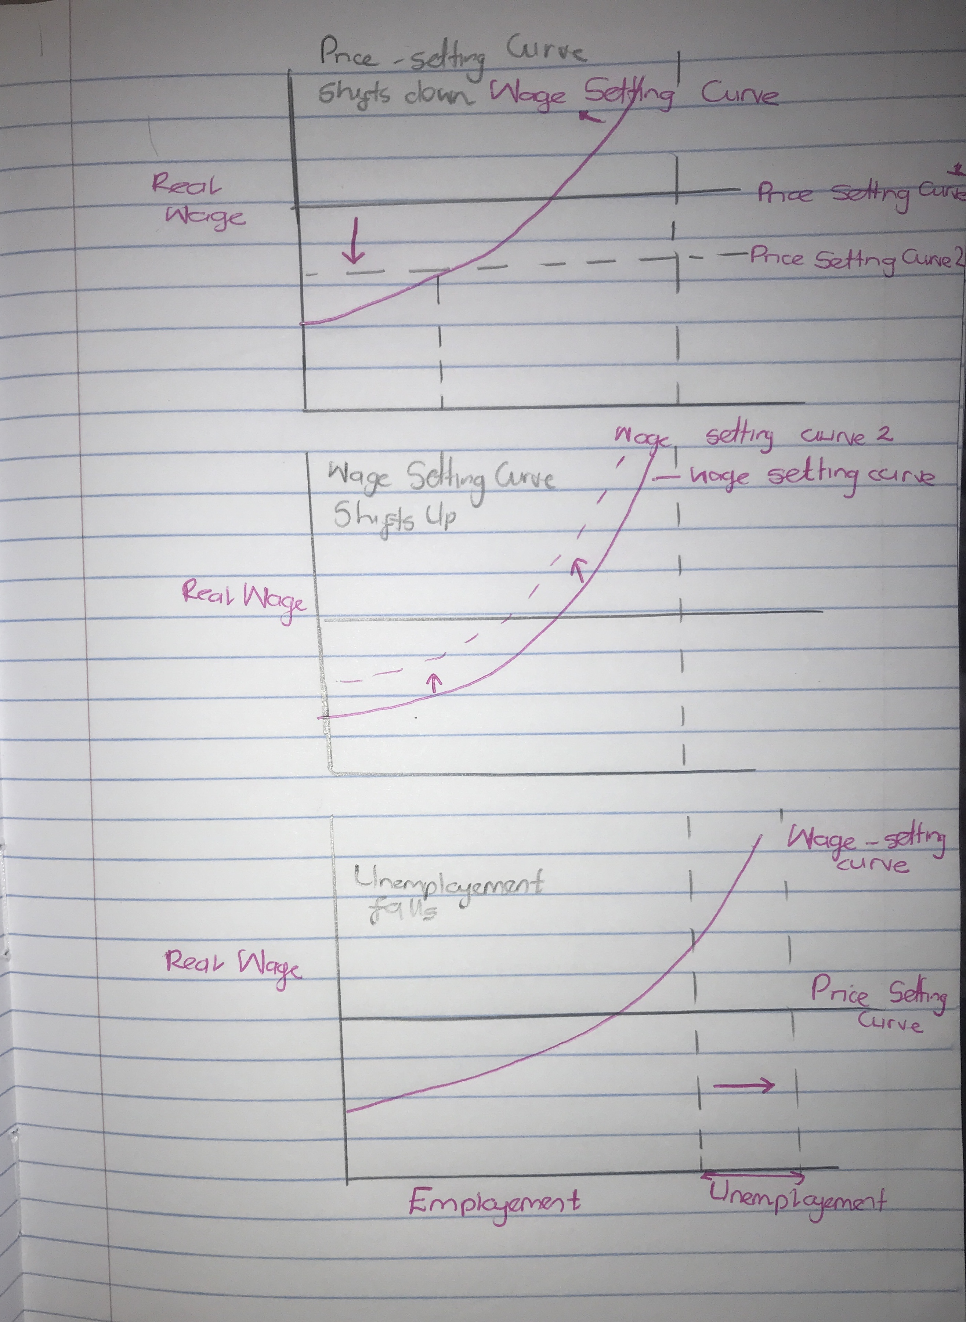

Two causes of the inflation as suggested in lectures:

Changing in bargaining power of firms - an increase in the bargaining power of firms:

This is caused by a reduction of competition, therefore allowing firms to charge a higher makeup which shifts the price setting curve down (diagram 1)

Changing in Bargaining power of employees: workers are demanding a higher wage; this results in an upward shift of the wage setting curve (Diagram 2)

In the first 2 curves, the level of unemployement has not changed.

In the third curve – the level of unemployment changes. This causes inflation because of the conflict of interest between workers and owners about the share of output per worker.

F) The Phillips curve suggests that there is a tradeoff between inflation and the level of unemployment. When the economy is not as good and there is low unemployment, there may be higher inflation.

Question 2

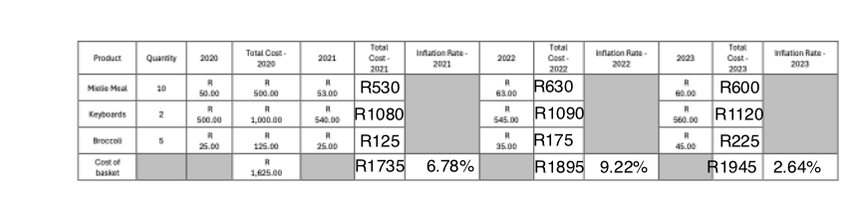

B) No, inflation rate is not a good indication of the inflation experience of all households across the income distribution in the country because different household experiences inflationary pressured:

Differences in consumption prices – different households have different income brackets and spend their money on goods and services differently. The CPI is usually used to calculate the inflation rate which is based on an average "basket of goods" that may not represent the actual spending habits of various income groups.

For example, low-income households spend most of their income on necessities such as food which may experience higher inflation rates in comparison to higher income households that spend a larger share of their income 0f luxury goods. For these households, the inflation rate could overestimate the actual price increases they face if luxury goods are less affected by inflation.

Access to substitutes: high-income households often have more flexible access to substitutes as they can easily substitute expensive goods with alternatives or adjust their consumption patterns to cope with inflation. However, low-income households may have fewer choices making them more vulnerable to price changes.

Different exposure to price shocks: different households are vulnerable to price shocks than others. For example, if there’s a sudden increase in energy prices, this would affect low-income households more as they rely and spend most of their income on energy in comparison to high-income households. The overall inflation rate may not reflect the true burden these households face from energy price increases.